activPAL Device FAQ & Instructions for Wear
What is an activPAL activity monitor?
The activPAL is a small activity monitor that records your daily movements, such as walking, biking, and running. It uses an accelerometer to detect body position and activity, allowing it to measure time spent lying, sitting, standing, and walking, as well as stepping rate and activity intensity.
The device is safe to use and does not provide real-time feedback. After you wear it for 7 full days and return it, we will download the data for study purposes. The activPAL is not a GPS tracking device and does not record heart rate
Note: Please start wearing the device once you receive it and leave the wrap on the device as this is how it stays waterproof.
Frequently Asked Questions
How long does the device hold a charge?
The device only holds a charge for 14 days and cannot be properly charged without the device software. Please make note of the date listed on the Ziploc bag as that is the date your device will die and will no longer record any activity. If you don’t put it on by that date, we will need to send you a new device in the mail.
The monitor is blinking, what does that mean?
The device should blink with an orange light, which means that it is programmed to start recording. When the light is blinking green that means it is charged and recording movement. If you do not see an orange or green light, that means the device is not working and will not record activity.
What should I do with the monitor at night when I go to sleep?
When you go to sleep for the night, please continue wearing the device.
What should I do with the monitor when I take a shower?
The activPAL is safe for short amounts of time in water and will be safe to wear. You are welcome to do what feels most comfortable to you. Please do not wear the activPAL for baths, hot tubs, or swimming.
The adhesive is bothering my skin, what should I do?
Some participants have trouble with the tegaderm material causing a rash or irritation. If this happens to you there are a few things to try:
- Apply an anti-irritation cream before placing the tegaderm on
- Use a large band aid to keep the device adhered
- Use a bandage wrap or pre-wrap material to keep the device on
What should I do if I must remove the device?
Place it flat on a stable surface such as a desk or table. Ensure it is in a safe place, as these monitors are very costly. Please document in the monitor log any instance when the device is taken off for more than 5 min.
Instructions for Placing the activPAL Device On:
Instructions | Demonstration Photo
Step 1:  - Grab your activPAL participant packet. Find the alcohol prep pad and gently scrub the skin where you will place the activPAL device (you can pick your preferred leg; if you need to switch legs during the 7 days that is okay).  - Please note the date listed on the Ziploc bag as that is the day the device will die. | 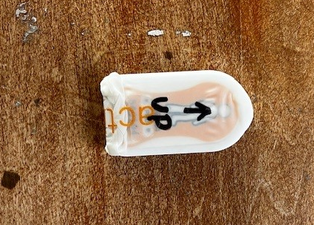  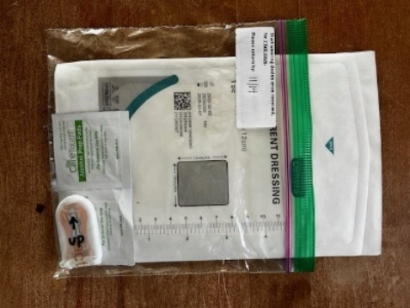
Step 2:  - While sitting down, position the activPAL on the thigh with the "up arrow" (round edge) shown in the picture halfway between your knee and hip.  - Tegaderm is a clear, waterproof film used to affix the activPAL to your thigh. Use the Tegaderm to attach the activPAL to your thigh. Please leave the wrapping on the device. | 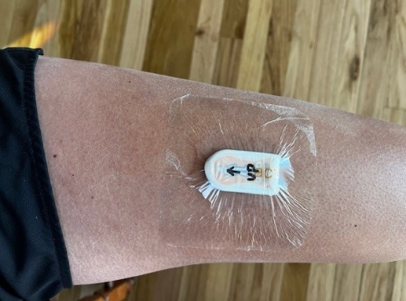  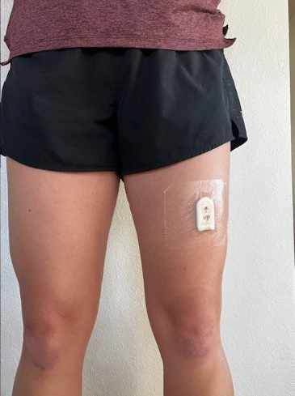
For additional demonstration on how to place the activPAL device on, you can scan the QR code to view the video or find it in your web browser here: https://www.youtube.com/watch?v=5wubDwIRmZ

